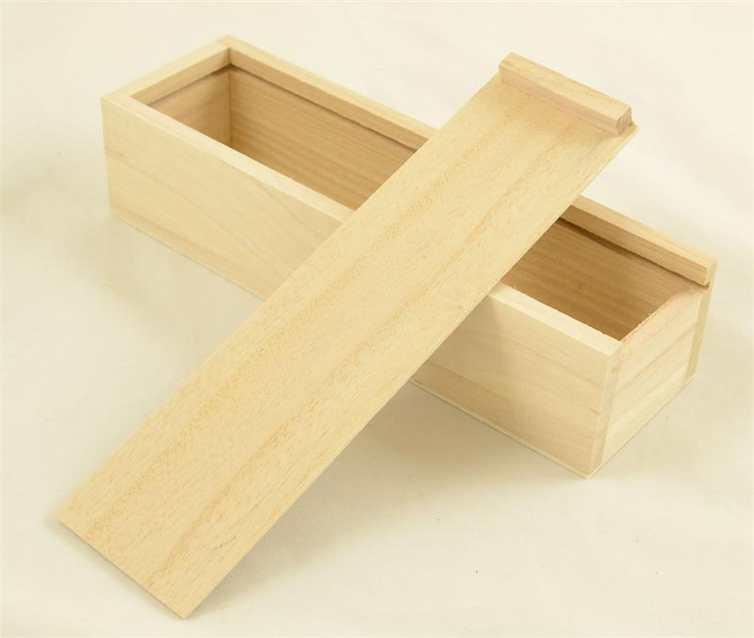

**Design Brief – Sliding lid box.**

You are tired of smaller items such as pencils, pens, jewelry or even marbles not having a place to live. So you will create a box with a sliding lid to store these items in. The materials that are available for you to use are:



* Grooved pine precut for different sized boxes.
* 3mm ply
* Quad or Dowel depending on handle type.

Choose the shape you want your box to be from the precut pieces. You must include rebate joints into the design of your box. You must incorporate a decorative feature into the finish of your box.

From the paragraph above, list three *constraints* (things the box must be) for the making of the box.

1.

2.

3.

Complete the four stages of the **Technology Process.**

**Investigate**

* Research different things about the project before you make it, like types of materials and where they come from or the types of glues or how you might decorate it.

**Design**

* Create different solutions to the situation. You can draw or sketch these using both hand drawing techniques and Computer Aided Design (CAD).

**Produce**

* Turn your ideas into reality, using safe work practices.

**Evaluate**

* Once you have finished, work out what you would do differently next time and what changes you would make to improve the product.

**Sliding Lid Box Evaluation Sheet**

Overall Mark /100

Investigation

* List 3 potential items to put in the box. Draw a sketch of each item and give its measurements. (Isometric Sketch) 5 marks
* Find two pictures from internet, magazines or hand drawn of decorations you will put on your box with the pyro pen. 5 marks
* Investigate how timber is taken from the growing tree to the timber we are using in the box? Explore the sustainability of this practice. 5 marks
* What are the three categories of wood and how can you tell the difference between each? 5 marks
* Complete the Onguard safety training unit ???????

Design

* Hand draw two Isometric box sketches showing different dimensions.

10 marks

* Hand draw two decorative designs you might use, drawn on the two box sketches. 5 marks
* Draw the box in Sketchup and include measurements and colour. (Follow the tutorials for this one) 10 marks

Produce

* List the tools you used and what they are used for. 5 marks
* No varnish runs. 4 marks
* No sanding marks. 4 marks
* Lid slides smoothly. 4 marks
* Nail holes puttied over. 4 marks
* Decorations are applied neatly 4 marks
* A complete production journal. 10 marks

Evaluate

* List the evaluation criteria & answers. (These are found in the constraints in the first section.) 6 marks
* List 3 problems you had and how they were overcome. 6 marks
* Take a picture of your finished product and include it in your folio. 3 marks
* Write a short paragraph about how well you think you completed this project and give yourself a mark out of 10. 5 marks
* All this information **must** be presented neatly in a folio and **in the order shown** above for the best marks.