Ukulele Design Brief
Design and Technologies

Investigation
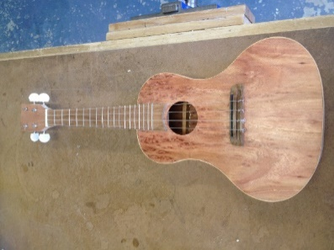
- Decide who the Ukulele is going to be made for. What style do they like, timbers, shapes etc.
- Research Tonal Timbers (see assignment sheet).
- Create a set of evaluation criteria for your finished Ukulele based upon the list shown in class.
- Research how the specific timber is grown and harvested. Give its country of origin, harvesting techniques, shipping and sales processes. Comment the sustainability of the processes.
- Explain the difference between design and chance.

Design
- Sketch the Ukulele on an A3 sheet of paper and use colour and annotation to show which timbers you will use based upon your research.
- Hand sketch a unique brand logo for the inside of the Ukulele that will reflect your personal style. Create a mood board to show where your inspiration comes from.
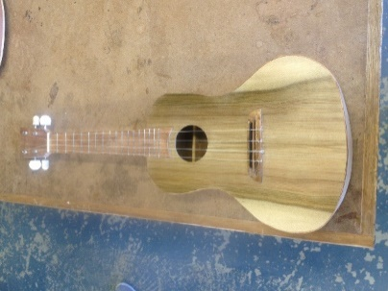
- Design the shape for the headstock in Autodesk Fusion 360.

Produce
- Keep a production diary and include pictures of your progress class by class.
- Complete the Onguard training and include a printed certificate of competence for each tool used.
- Complete the Ukulele. Product will be assessed for accuracy, quality of finish, and unique design.
- Create a “Swing Tag” for the Ukulele detailing its correct use and care.

Evaluation
- Measure your finished product against the evaluation criteria already set. Be critical.
- What would you improve if you made the Ukulele again
- Write a paragraph describing how you feel about your completed Ukulele. Comment on things like; how you used your time; is the finished result what you imagined. Explain why or why not.
- All work must be completed and presented in a folio in the order shown.

