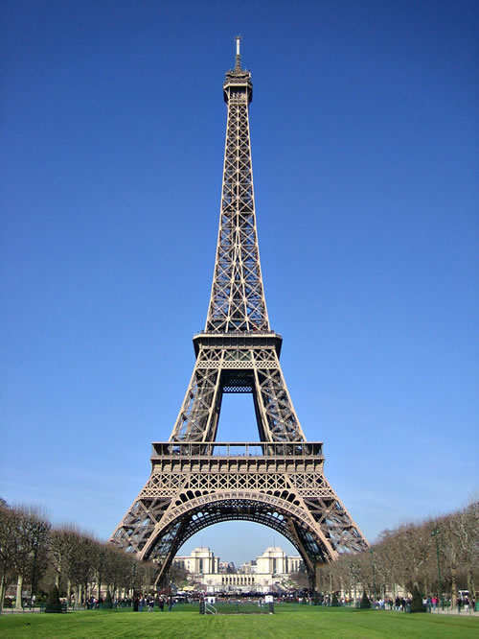
Monster Tower
Design Brief
You are to work in pairs to build a tower that will hold the most weight. The tower must have a platform at the top that is a minimum of 800mm tall. The platform at the top of the tower must be a minium of 200 x 200mm. The weight of the tower must not exceed 500gm. You have been given 4 weeks to complete the task. Testing will begin ?????.

You have been given:
- -3mm ply 600x500mm
- -7.2m (3 lengths) of 6mm diameter dowel
- -One stick of hot melt glue

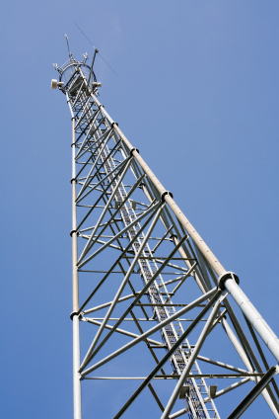
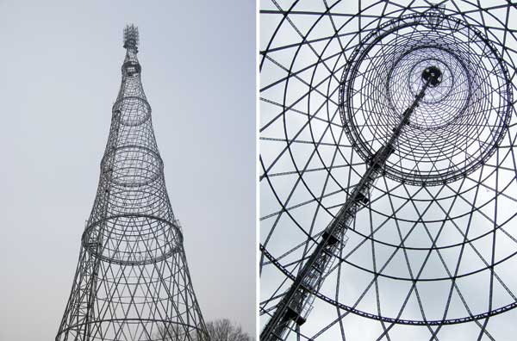
There will be prize money of $20 for the team whose tower can hold the most weight.
Project:
You must also complete the Technology Process and all the following is to be presented in a display folder on the test day.

Investigate:

- Write down the 4 constraints from the instructions above.
- Write down 4 considerations for the construction of the tower.
- Using books or the internet collect images of different tower designs. You must include at least 10 different designs.
- Use the following website to discover how to build strong structures. http://www.learn4good.com/kids-games/simulation/build_bridge_across_canyon2.htm
- Describe the 5 types of forces. Show a diagram of each one. Give an example of each one.

Design:
- You must sketch a minimum of 3 full A4 page designs of possible towers that you could build, with dimensions.

Produce:
- Make the tower.
- Keep a diary of the production process and what you complete each class.
- Include a picture of your finished tower.
- Show where 3 different forces are at work on your tower. Show these on your picture.

Evaluate:
- Test the tower and record how much weight it carried.
- Record how the tower broke and see if you can explain why it broke where it did. Use a diagram.
- What would you change to fix the place where it broke?
- Write a paragraph about your performance on this project and how well you worked together with your partner.

