Professional Development Program

To the Attention of Teachers of:
Product Design & Technology / Systems Engineering / Visual Communication & Design

21st Century CAD Graphics

CREO 2.0 TRAINING formerly Pro/Engineer /Schools Edition.
The world’s leading Product Development Solution
You have to do 12 hours training, complete a task, then you get a DVD with a licence for 100 students AND, the students can take the software home to use and practice.  With no other administration fees The software is FREE! There is a huge range of on line resources.  A DVD of video tutorials of all processes, lesson plans and work units is included.  Take this opportunity to mix with your colleagues, share resources and ideas and develop strategies for implementation of Australian Curriculum in Victoria.  See www.ptcschools.com www.ptc.com/for/education/gallery/index.htm  and check out YouTube search for Creo2  NEXT TRAINING COURSE: | 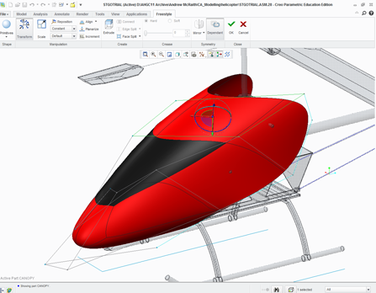  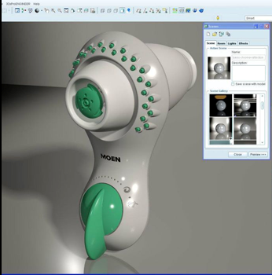
Huntingtower School, Mt Waverley.
Saturdays August 17 and 24, 2013.
9.00 am – 3.30 pm
Cost: DATTA.Vic members $286
includes lunch both days,
program licencing and support.

About PTC Creo Parametric http://www.ptc.com/company/community/schools/creo.htm
PTC Creo Parametric is state-of-the-art 3D CAD software (formerly called Pro/ENGINEER). You can create 2D sketches, 3D models, assemblies, drawings, rendering and more. Schools across the globe have been using this tool for more than 10 years.
Creo is a state-of-the-art design software. You can transform product ideas into detailed virtual models using 2D and 3D tools, and perform powerful scientific and mathematic analyses.

Benefits of PTC Creo 2
- Engage student interest with cutting edge graphics and interactive virtual models.
- Foster student creativity with limitless design opportunities.
- Explore the science and maths behind product development.
- Produce detailed designs for manufacturing and communications.
- Export designs for CNC Milling and 3-D Printing
- Free student and teacher licenses for in school and home use.
- PTC Creo offers the best preparation to become an Engineer of the Future, by putting design, analysis, and simulation tools directly in the hands of students
