3D printing: saviour or piracy tool?

Brad Howarth
February 7, 2012
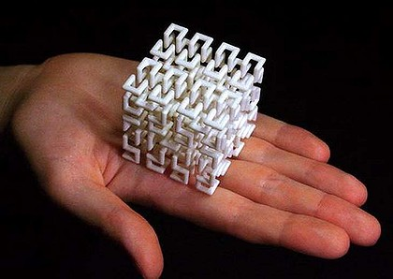
Print your own art: a 3D version of a Hilbert space-filling curve, printed on demand via Shapeways.
What if people could print spare parts and consumer goods on site? 3D printing is developing fast.
The advent of 3D printing is enabling consumers and businesses to create everything from intricate metal jewellery to customised plastic iPod cases, but the ease with which designs can be turned into objects holds open a door to a new wave of digital piracy.
3D printing involves the gradual layering and bonding of materials such as plastics, ceramics and metals to build up a 3D object. It has been used in manufacturing for rapid prototyping, where its convenience has outweighed its high cost.
Now the technology is poised to go mainstream in the production of parts and consumable items. The German 3D printer manufacturer EOS, for instance, is now able to create metal objects as robust as cast parts, and often as strong as forged parts. More than half of its printers are sold for production manufacturing, rather than prototyping, with strong interest from the aerospace industry due to the complexity and lightweight nature of printed parts.
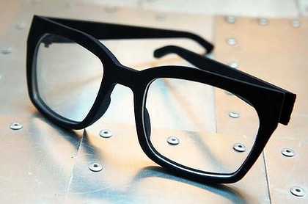
Marcello Mastroianni-inspired glasses by Australian designer Andrew Simpson of Vert Design, printed on a 3D printer, Shapeways. Photo: Supplied.
Mashable today reported the case of an elderly British woman who recently received a transplant of a jaw bone produced by a 3D printer.
According to Jackie Fenn, vice president at the analyst firm Gartner, recent falls in printer prices are creating a whole new industry.
"It is starting to spawn a whole set of small bureaus that can complete customised individual items," Fenn said.
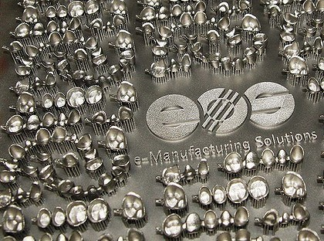
A platform with up to 450 patient-individual dental crowns and bridges built on a EOS 3D printer using the metal alloy cobalt-chrome. Photo: Supplied
Eventually some designers might stop manufacturing and sell their 3D designs directly to buyers to print out themselves.
"Rather than Canon manufacturing thousands of replacement lens caps and shipping them off to photo stores, they could just sell the design, and have you make one in your 3D printer or at the local bureau."
Cheap 3D modelling tools mean people can easily create their own designs, and created opportunities for companies like Paris-based Sculpteo, a printing bureau for customised plastic objects. Co-founder Clément Moreau believes mass customisation through 3D printing would become mainstream in three to five years.
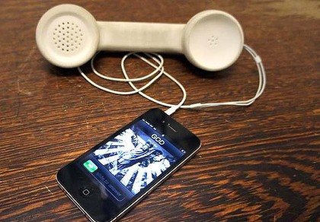
A 3D printed handset for iPhones, by Australian designer Andrew Simpson of Vert Design, Shapeways. Photo: Supplied.
"Every plastic object on Earth is a very good candidate, from doorknobs to the buttons of a jacket," Moreau said.
Similarly, New York-based Shapeways operates a marketplace where buyers can purchase personalised objects or upload their own designs.
Spokesperson Carine Carmy said that while the service started by printing hobby objects such as model train accessories and abstract art, it is now used to create commercial objects such as customised smartphone cases. There are more than 4500 shops on the site, but unlike other e-commerce sites, if buyers can't find what they want, they can design it themselves.
Carmy said one-off items could be printed in materials such as sterling silver at a fraction of the cost of other processes.
"It's an entirely new economy that we are creating. Designers can focus on design and not on fulfilment."
Carmy said Shapeways had strict terms of service precluding users from printing objects that infringe copyright. She said her company would investigate any user suspected of infringing, but added that piracy was something the design community still needed to contend with.
"Product design has yet to be affected by technology in the same way that the music industry has, and so I think it is still an open question that we will have to answer with our design community and our customers."
Similarly Moreau said Sculpteo had no intention of becoming a platform for piracy.
"Some of our competitors are not so afraid of this, but we fully respect copyright and as far as we can we enforce our users to respect copyright."
According to Bruce Arnold, a lecturer in the School of Law at the University of Canberra, the potential for object piracy is currently limited by the need for a skilled designer to copy the original object into a 3D model. While 3D scanning technology is in development, it will only enable a printer to create the appearance of an object, not its contents.
"For some purposes, appearance is everything; for other purposes functionality is really important," Arnold said.
Just as with existing counterfeiting options, Arnold said that many consumers would still prefer to buy the original item. But for some designers, he said protection may be better achieved through instant prototyping and continuous product change rather than intellectual property law.
Read more: http://www.smh.com.au/it-pro/business-it/3d-printing-saviour-or-piracy-tool-20120207-1r2mm.html#ixzz1mJAKGUDZ

