SURFWEAR

Student: Form: Date:

The Design Brief:
Jargon Buster

Design Brief- the problem or information a designer needs

Prototype - a model or first of its kind

Casting - object made with a mould

Specifications – detailed description

White metal JA6- a low melting temperature, non –toxic metal

Evaluation criteria- on what you will assess the success of your prototypes
You are a designer of wearable art. International company RIPCURL has asked you to design & produce some prototypes of surfwear for their new range. They want to see samples made of cast metal and also bright colourful plastic.

Specifications:
Casting using white metal JA6 into a plaster mould. Hole needed for neckband or place to attach a brooch pin.
Acrylic plastic, cut to shape, rounded, sanded & polished. Hole drilled for neckband or brooch pin attached.

Evaluation Criteria: Write these as questions

Investigation:
View the DVD-Jewellery series #5 part 2 on surfwear jewellery
Collect your own pictures of ‘Surfwear’ and paste them on the back of this sheet. ‘Google’ to find jewellery sites and download some pictures of designs you like.
Design:
Sketch 3 ideas for your own ‘surfwear’ here. Tick the ones you will use for your prototypes

Evaluation:
Using your evaluation criteria above rate yourself on the scales with 1 being poorly, 5 being perfectly.
Teacher Comment
Criteria 1/ 1---------2---------3---------4----------5

Criteria 2/ 1---------2---------3---------4----------5

Criteria 3/ 1---------2---------3---------4----------5

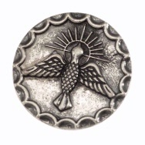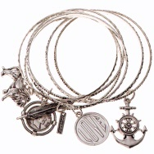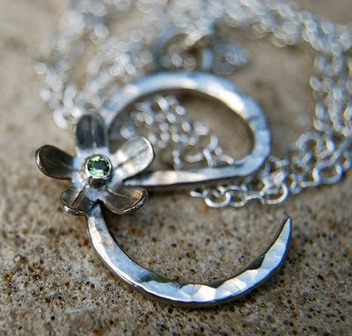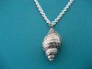
SURFWEAR

GALLERY

