OF FAIRIES, MONSTERS, GHOSTS AND CREATURES….
Contemporary Children’s Book Illustration from Germany

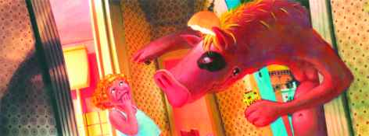
Exhibition open 18. Aug – 05. Sep 2008, 10.00 am to 5.00 pm
Australian Academy of Design
220 Ingles Street, Port Melbourne

Workshop Booking Form & Tax Invoice
ABN 585 592 579

Workshop for tertiary art and design students
Tues 02.09.08, 9.30am-1.30pm - $25.00 per person

This Workshop will be run by the well known German Illustrator Karoline Kehr. Karoline will present her work and technique of building a landscape from recycled materials, and placing characters within that landscape, using digital photography and painting in of characters

Each student will then work to create their own book cover using Karoline’s technique.
Students should bring their favourite book to create a new cover and a digital camera (if you have one).

Places are limited and the Workshop is subject to availability at the time of booking
Deadline for Submission is: 18 August, 2008!

Name:
E-mail:
Institution attended: Year Level:
Tel:
$ TOTAL

Please send a cheque together with this form via Post, alternatively you can Email or Fax this form no later than Monday 18 August to:

Sandra Boyd, Australian Academy of Design, PO Box 5200 South Melbourne, 3205
Fax (03) 9676 9066, marketing@designacademy.edu.au

For payments via Electronic Funds Transfer:
Australian Academy of Design, ANZ Bank, South Melbourne
BSB 013435 account number 351721571
Please itemise your payment with “Your Name: Goethe Workshop”

