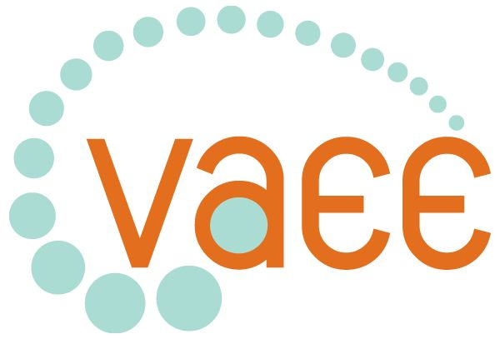
Professional Learning Program 2008

Your Voice in Education for Sustainability

Sustainability, the Integrated Domain
Theme:
Amongst the VELS Domains you find there is no Education for Sustainability domain!
- Nor does it appear in either of the other strands!
- However it is mentioned in many places throughout VELS Documentation.
- This professional development activity is designed to help you develop a meaningful Education for Sustainability program that draws on many of the traditional domains and incorporates aspects of the two other VELS strands.
- While much of this program focuses on an Integrated Curriculum, much of the material is relevant to a traditional domain based approach.

Date: Wednesday, 5th March 2008
Time: 9.00am - 3,30pm,
Facilitators: Ian Jenkin & Maria James- With material from a team of practicing educators
Venue : Statewide Resource Centre
150 Palmerston Street
Carlton

Details:
This professional development activity will commence with Maria James, explaining the place of Education for Sustainability in Victorian Schools, and its relationship to VELS.
- Following this Ian Jenkin will lead a workshop demonstrating how you can lay the foundations for your program.
- How to organise your time table to make an integrated program work.
- Followed by a simulation game scenario can become the vehicle for driving a cross domain Environment unit drawing on a wide range of studies.
- In the afternoon session we look at ways we can Support our program from outside of the school
- Finally we shall look at how Education for Sustainability can have Spin offs into a range of other domains and educational outcomes
- Lunch and Morning Tea provided.
- For information contact Ian Jenkin on (03) 9349 1806 or via email at ijenkin@vaee.vic.edu.au

Cost: $80 VAEE members, $100 non-members
RSVP: [27th February 2008] Cancellations after that date cannot be guaranteed a refund
Bookings close 5 working days before the listed date.
DON’T MISS OUT BY DELAYING YOUR BOOKING

Book your place now by sending a booking form to the VAEE office.
It is planned to offer this Session in a number of Regional Locations, during Semester 2, if there is sufficient demand or it can be offered as a whole school Professional Learning Activity. Ask us about it

Your Voice in Education for Sustainability

EVENTS BOOKING FORM

Name: __________________________________________________________________________________

Organisation: _______________________________________________________________________________

Address: __________________________________________________________________________________

Postcode: ___________Phone number: ________________Fax number: __________________

E-mail address: _____________________________________________________________________________

Are you a member of the VAEE? (Please circle) Y / N

Please give the following details for the event you want to attend:

Name and date of event Sustainability, the integrated domain 5th March 2008

Number of people attending (insert number in boxes): Members Non-Members

Names of people attending: _________________________________________________________________
_________________________________________________________________________________

If you are a teacher please complete:

Please tick appropriate category: Catholic Independent Government
If you teach at a government school please circle the applicable region:

Eastern Metropolitan Northern Metropolitan Western Metropolitan Southern Metropolitan

Barwon South Western Gippsland Grampians Hume Loddon Mallee

Please provide payment details: Bookings must be accompanied by Cheque/Card details/ or School Purchase order No

CREDIT CARD – Please debit my (please tick the appropriate box):

MasterCard Visa Bankcard

Name on Card: __________________________________________________________________

Card number: __ __ __ __ / __ __ __ __ / __ __ __ __ /__ __ __ __

Expiry Date (month/year): __ __ / __ __

CHEQUE – Please mail cheques payable to the Victorian Association for Environmental Education.
** Please fax or post this form to the address or fax number shown below **

