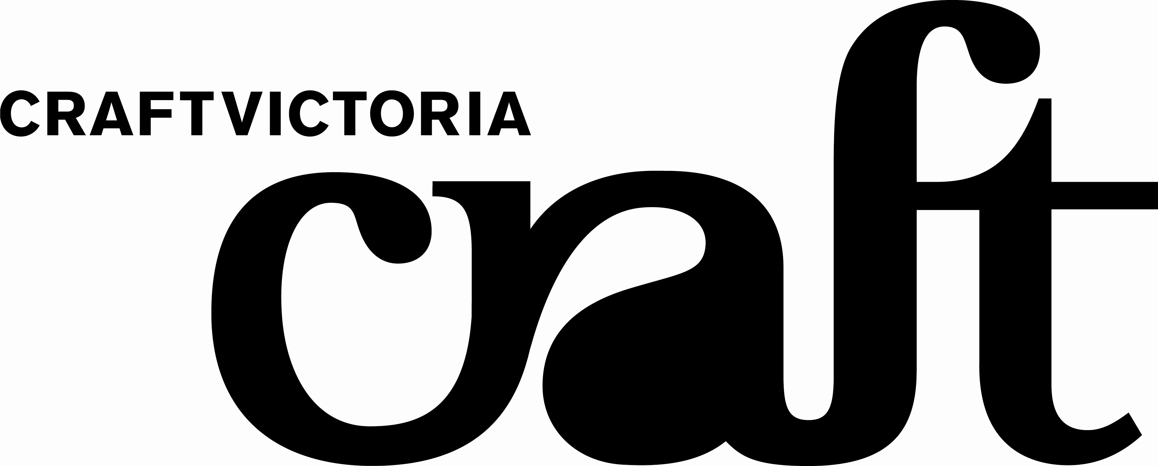

FOR IMMEDIATE RELEASE: EXHIBITIONS
Gallery 2 from Thursday 31 January to Saturday 1 March, 2008
Brenda Page Once Upon…

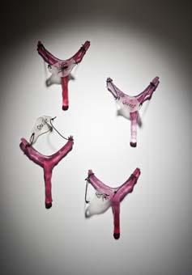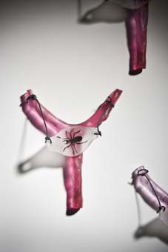
Images: L-r: Brenda Page, In Other Words and In Other Words (Detail), Glass, 2007. Images courtesy of David McArthur.

There is a theory that personalities are developed and set within the first seven years of childhood. Once Upon a Moment explores the territory of what it is that makes us who we are. Over the past 12 months Brenda Page has been gathering stories from family members and friends, particularly children between five and seven years of age. From these interviews she lists the potent images and symbols that arise to create composite stories that are suggestive and dream-like. These images are then incorporated into and on the glass Page creates. Many of the collected stories relate to defining moments which have transferred their energy into the object, allowing the glass to tell a tale.

The sculptural objects directly relate to early childhood toys such as; skateboards, skates, sling shots, paper airplanes, puzzles and dolls. The work is produced using a variety of kiln forming techniques; fusing, slumping, lost wax casting, painting and screen-printing.

Page notes, “Most work has required many hours of labour with some of the pieces requiring up to 90 hours of firing time in the kiln. I believe the use of glass intensifies the notion of fragility and vulnerability, making the stories more potent”.

KEY DETAILS
Exhibition  Thursday 31 January to Saturday 1 March 2008  Opening  Wednesday 30 January 6 to 8pm, artist floor talk 5.30pm | Venue  Craft Victoria, 31 Flinders Lane, Melbourne, Victoria, 3000 Australia  Hours Tuesday to Saturday 10am-5pm
For further information contact
Nella Themelios, Curatorial Officer, Craft Victoria, 61 3 9650 7775 or nthemelios@craftvic.asn.au.
Artist interviews & print-ready images available on request. Other Craft Victoria info: www.craftvic.asn.au

Also…In the Window:
January 21 - February 10, Rochus Urban Hinkel and Tim Schork with Jen Addison, Natassya Arief, Thomas House, Vaughan Howard, Anna Semenova and Carri eTjandinegara, A Notion of Space.
Monday 3 March - 23 March, WALKA, Melbourne: Bond from the Inside Out. Developed in conjunction with The South Project and part of the 2008 L’Oréal Melbourne Fashion Festival Cultural Program.

