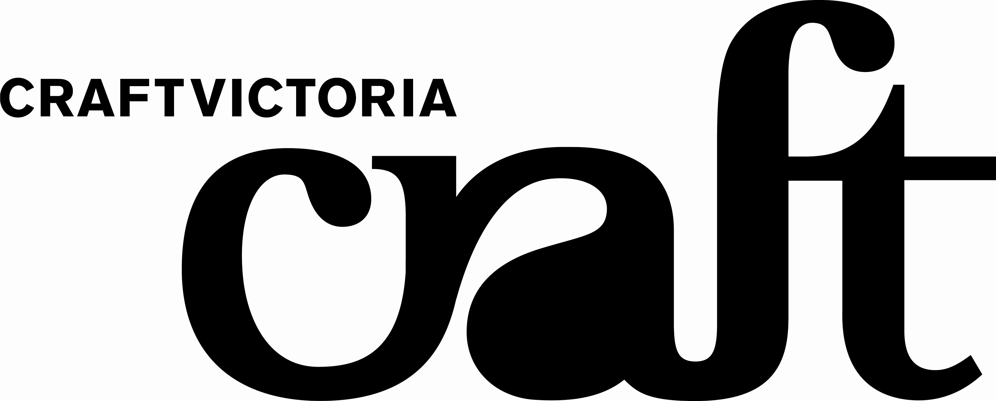

FOR IMMEDIATE RELEASE: EXHIBITIONS
Gallery 3 from Thursday 31 January to Saturday 1 March, 2008
Caz Guiney Precious Nothing

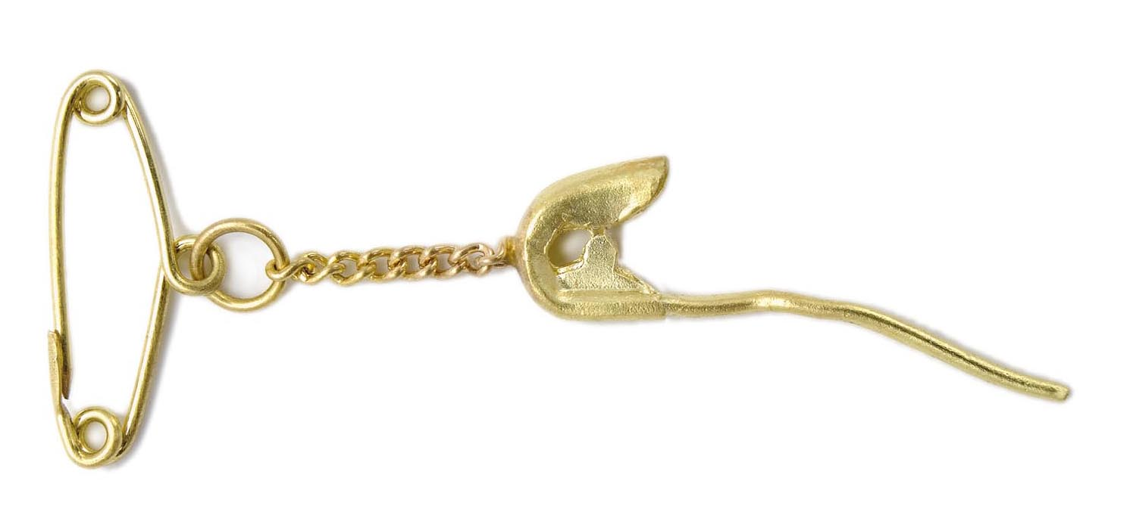

Image: Caz Guiney, 'Pinpin', 18ct yellow gold Brooch (actual size 10mmx25mm). Photographer: Terence Bogue.

Precious Nothing is a collection of finely crafted 18 carat yellow gold jewellery pieces by jewellery artist Caz Guiney. Guiney uses the city of Melbourne – its landmarks, debris, layers of grime and intimate corners - as inspiration to create a precious wearable memory; a memory of a seemingly non-precious street life; a memory of the hidden (and not so hidden) life of a bustling city; a ‘real’ souvenir.

The body of work is complemented by an installation carefully designed to engage the viewer in the minute details of a familiar city: the texture of the steps at Flinders St Station, a piece of tissue stuck to the wall by the Yarra River, pigeon poop from St Patricks’ Cathedral and lost costume jewellery found in city street gutters.

KEY DETAILS
Exhibition  Thursday 31 January to Saturday 1 March 2008  Opening  Wednesday 30 January 6 to 8pm, artist floor talk 5.30pm | Venue  Craft Victoria, 31 Flinders Lane, Melbourne, Victoria, 3000 Australia  Hours Tuesday to Saturday 10am-5pm
For further information contact
Nella Themelios, Curatorial Officer, Craft Victoria, 61 3 9650 7775 or nthemelios@craftvic.asn.au.
Artist interviews & print- ready images available on request. Other Craft Victoria info: www.craftvic.asn.au

Also…In the Window:
January 21 - February 10, Rochus Urban Hinkel and Tim Schork with Jen Addison, Natassya Arief, Thomas House, Vaughan Howard, Anna Semenova and Carrie Tjandinegara, A Notion of Space.
Monday 3 March - 23 March, WALKA , Melbourne: Bond from the Inside Out.
Developed in conjunction with The South Project and part of the 2008 L’Oréal Melbourne Fashion Festival Cultural Program.

