

FOR IMMEDIATE RELEASE: EXHIBITIONS
Gallery 1, 2 and 3: How You Make It (touring 2008 and 2009)
Curated by: Kate Rhodes, Craft Victoria
Exhibition Dates: Thursday 6 March 2008 to Saturday 5 April 2008

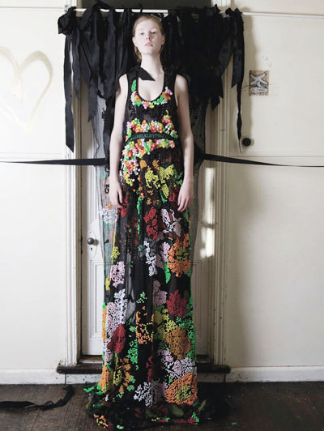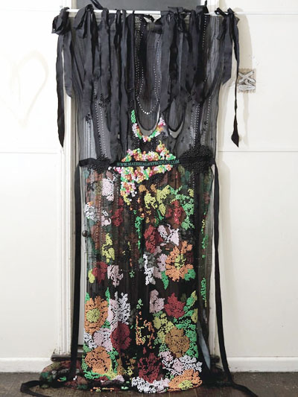
Images: MATERIALBYPRODUCT. Creative Direction: 3 Deep Design. Photography: Susan Grdnac

The designers in How You Make It not only create new garment forms and new ways of wearing clothes, they develop new design systems. How You Make it explores artisanal fashion design practices that draw on traditional tailoring techniques to form contemporary collections. Here we encounter unique materials, tools, techniques and templates for making. These designers have developed a conceptual practice in the space between craft and design.

This fashion design is characterised by its multidimensional and structurally complex nature. In the finished garments we see the tangible results of considered choices about when, where and how to cut fabric. Existing garments are deconstructed: unpicked, reconfigured and reworked, using fine tailoring and conceptual templates in order to create a new style of clothes. Related modes of working involve systems or patterns of construction as a leaping point into tailoring from new materials. These conceptual Australian fashion designers open a dialogue between craft and design that places the focus back on how and why objects are made. The focus of these designers on tailoring links fashion design and craft.

How You Make It will be accompanied by an exhibition catalogue and will include new works from the following designers: MATERIALBYPRODUCT (Susan Dimasi and Chantal McDonald), S!X (Denise Sprynskij and Peter Boyd), Anthea van Kopplen, Project (Kara Baker and Shelley Lasica), Ess. Laboratory (Hoshika Oshimi and Tatsuyoshi Kawabata), Paula Dunlop, Toby Whittington and Simon Davies.

How You Make It is a collaborative project between Craft Victoria and Object Gallery funded by Object’s National Exhibitions Strategy and NETS Victoria. Presented as part of the 2008 L'Oréal Melbourne Fashion Festival Cultural Program.

KEY DETAILS
Exhibition  Thursday 6 March 2008 to Saturday 5 April 2008  Opening  Thursday 6 March 2008, 6 to 8pm, artist floor talk 5.30pm | Venue  Craft Victoria, 31 Flinders Lane, Melbourne, Victoria, 3000 Australia  Hours Tuesday to Saturday 10am-5pm
For further information contact
Nella Themelios, Curatorial Officer, nthemelios@craftvic.asn.au, Craft Victoria, 61 3 9650 7775. Artist interviews and print-ready images available on request. Other Craft Victoria information: www.craftvic.asn.au

