

Throughout the year Melbourne Girls’ College has demonstrated its commitment to the environment and sustainability through a range of innovative projects in which students are actively involved. Our Solar Energy Launch on Monday November 20th is a celebration of the hard work of staff and students and the new educational opportunities offered to the Melbourne Girls’ College community.

The proactive approach to sustainability at M.G.C. includes the installation of a solar system which generates approximately 2,800 kWh per annum. This new solar system provides electricity for the college and will cut the school’s greenhouse gas emissions by three tonnes per year. The use of renewable energy sources has been promoted throughout the wider community and students have been learning about the harmful impact that global warming has on the world.

Another aspect pertaining to the extra-curricular studies in sustainability at Melbourne Girls’ College is the RACV Energy Breakthrough race. This event is a 24-hour vehicle race, held annually and is entered by schools from all over the state. Melbourne Girls’ College is entering two teams into the R.A.C.V. Energy Breakthrough in 2006 – our fourth year participating in the event. Team captain Erika Codognotto, returning for her second year with the team says that “it is a fantastic event that engages students with engineering and the environment at the same time”.

“I really like the fact that we get to build a race car, I feel like we are actively contributing to a project that is making a difference to the world” – Year 9 Team member

Throughout this year a team of 40 girls from Years 7-11 have been working with a group of Engineers from B.A.E. to develop two vehicles. Students have researched issues such as global warming and our dependence on fossil fuels as impetus to their designs. One of the vehicles, to be raced by the junior students, will be human –powered. The vehicle to be raced by the older students is a hybrid electric / pedal-powered machine, powered using solar energy, so as to create zero emissions.

The Teams two cars are called CARcharias and Mydas after Carcharias Taurus (the Grey Nurse Shark) and Chelonia mydas (the Green Sea Turtle). The shapes of each vehicle has been modelled on the dynamic shape of these two creatures, which have proved to be a great way for the students to study aerodynamics. But shape is not the only reason these animals have been chosen for inspiration. Both of these organisms are at great risk of extinction due to global warming. The continued use of fossil fuels threatens to increase sea levels and sea temperatures, which could be the final nail in the coffin of these wonderful marine creatures. At the Launch of our 2007 solar projects MGC students will explain just how this may happen and what YOU can do to avoid it.
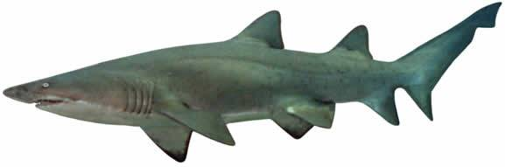
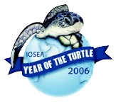
M.G.C. Solar Energy Launch
3pm for 3.15pm start
Melbourne Girls' College
Yarra Boulevard Richmond Vic 3121
Enter via Gate one
Further information: Andrew Vance
avance@mgc.vic.edu.au Ph: 94288955

