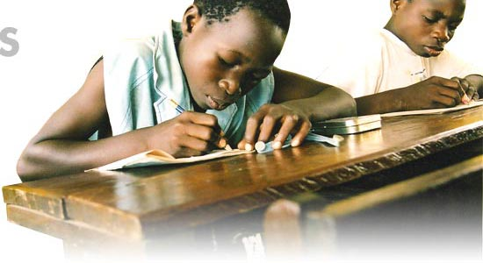
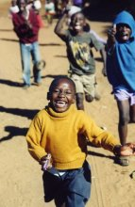
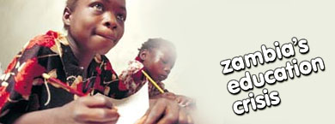
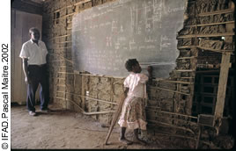
You might not be able to save the world but you can make a difference to the kids of Zambia by donating any excess reading material you might have in your schools.

Why Zambia? Quite simply we are able to help because the most expensive part of any book donation scheme has been taken care of for us. Transport, for the books, has been arranged without cost. All that is required is for books to be delivered to Anderson’s Creek Primary School and they will be sent, in bulk, to Zambia. They will be of immediate use to children.

English is the official language of Zambia so that texts can be put to use in all schools.

Classes can exceed 80 students per grade
….. and they have precious little to read!

Books for primary school children is at a premium but books of a more challenging nature are also welcomed.

If you would like more information please contact:
Des McKenzie
9844 2757

Please forward any contributions to:
Anderson’s Creek Primary School
Drysdale Road
WARRANDYTE 3113

These kids need
...books of any kind!
These kids need
...books of any kind!
All donated material must be packaged in cardboard boxes and delivered to the school above by Friday, 27th July, 2007.

