Accounts Payable
Accounts Receivable
HRMS Local payroll

R
C21F BAS Audit Trail
ATO Paper BAS return



or

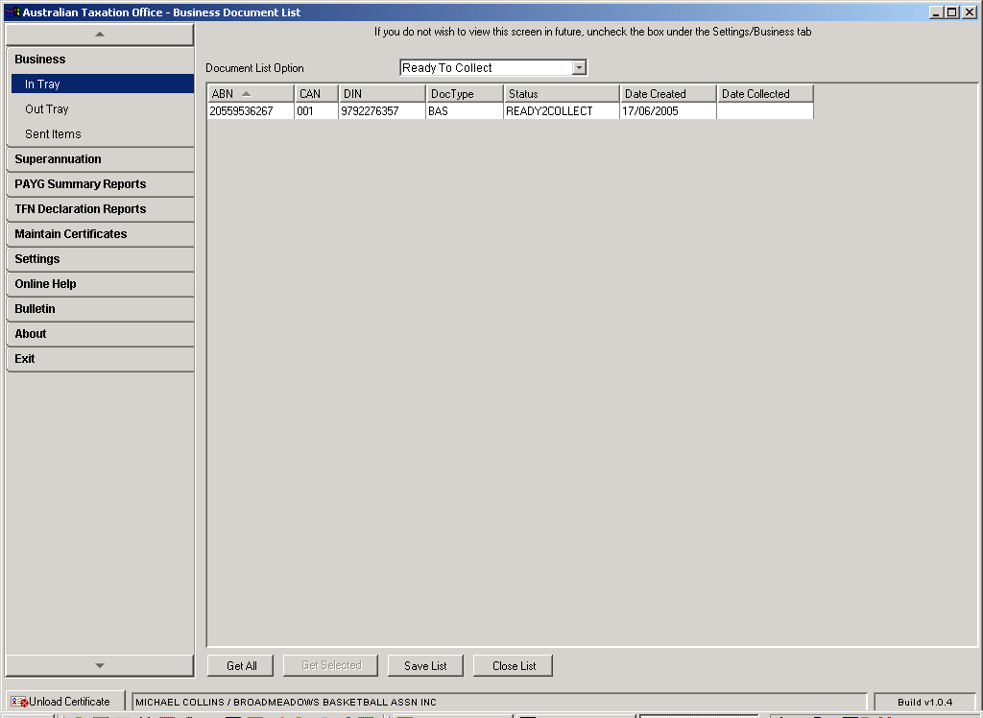

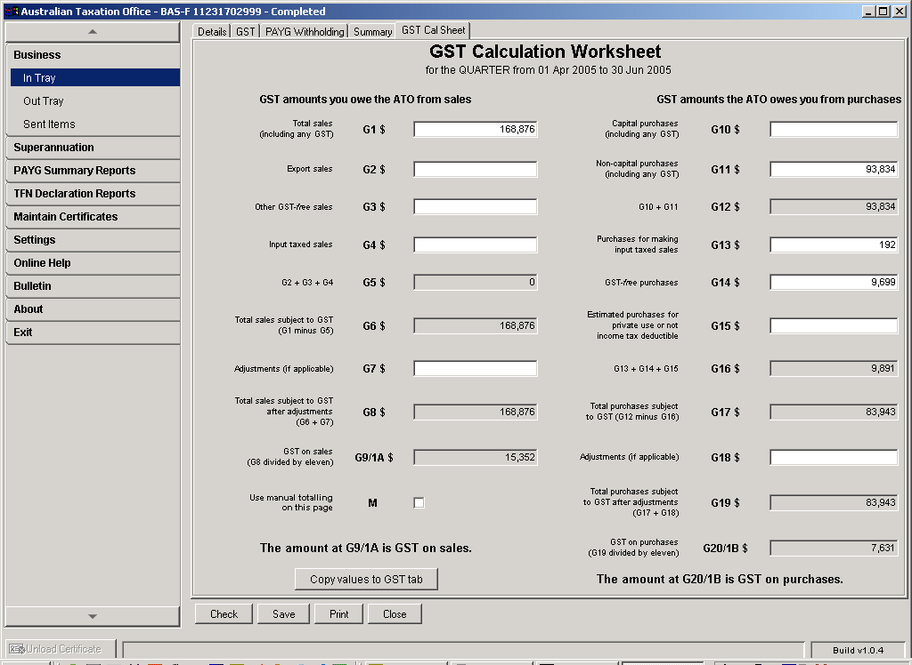

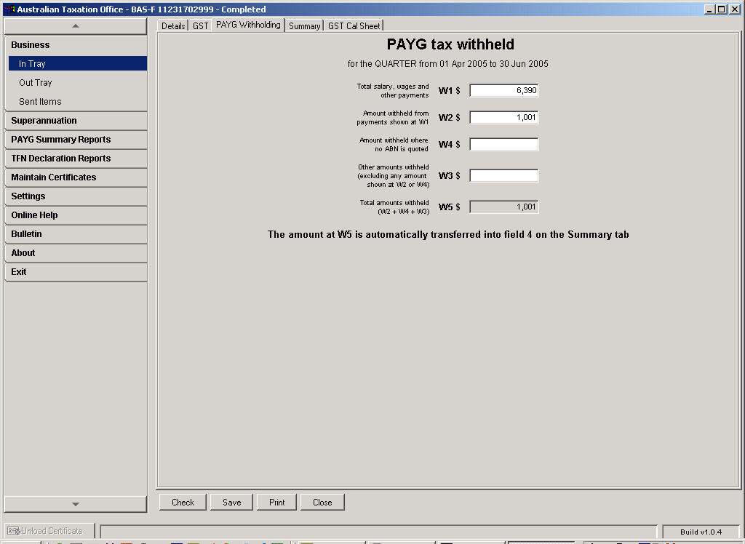

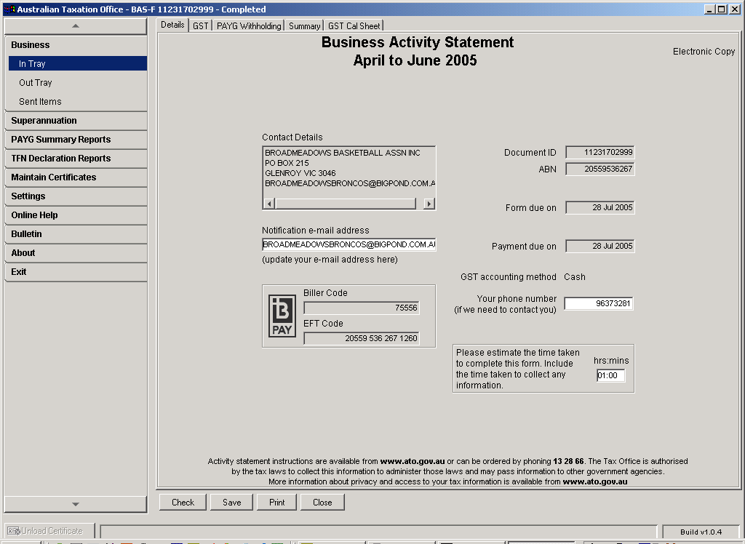

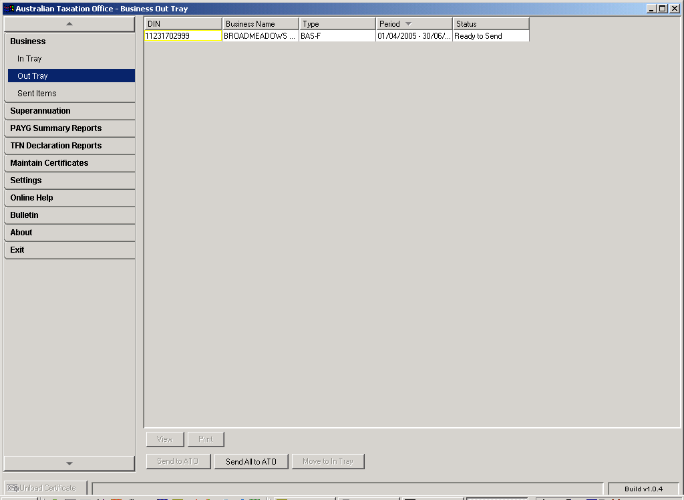

THROUGH ECI INTERFACE

1. Enter Accounts Payable, Accounts Receivable transactions in CASES21Finance

2. Enter Local Payroll Transactions into C21Finance

3. At end of month/quarter, after End of Period processes are complete run the Final BAS Reporting task which will generate the GL21412S GST Calculation Worksheet for BAS-Final Report

4. If lodging on a paper return

5. If lodging electronically
* Log on to ATO ECI interface
(using software loaded on your PC)

* On the ECI side menu - go to “Business”, “In Tray”,

* Ensuring the drop down is on “Ready to Collect” highlight the selected return and then, from the buttons at the bottom of the screen, select “Get Selected”

* Double click on BAS return you wish to enter data

* Go to “Calculations Sheet” tab,
enter data from similar boxes G01, G03, G04
G10, G11, G13 G14 to C21F BAS report

* Make any adjustment entries at G7 and G18

* When completed, click “Values to GST” tab button

* Go to “PAYG Withholding” tab
(tab on top of calculation page)

* Enter local payroll gross at W1, related tax withheld at W2 and any No ABN Tax Withheld at W4

* Complete the time estimated to complete the return on the “details” page

(Include in this time estimation time used to run C21F BAS reports, make adjustment entries etc.)

* “Save” and “Close” BAS return

* Highlight return required & click on “Move to Out Tray”

* Go to “Out Tray” on side menu, highlight return and click on “Send to ATO” button.Arrange EFT payment to ATO (if refund this will be direct debited to nominated school bank account.

