

TaxBriefs is a DoE Financial Services Division electronic newsletter written
for schools, principals, SSOs and Business Managers.
It provides a snapshot of taxation matters and reminders of tax events affecting schools that have occurred throughout the term, with links for further research.
TaxBriefs will usually be provided once a Term (mid Term).
Users are welcome to provide feedback using the link below.
In this term’s edition

What’s Hot?
- 2007 FBT Returns for Schools
- Nil Returns cannot be lodged until 1st April
- Some FBT Thresholds are changing, effective 1 April 2007
- Entertainment & FBT Decision Flow Chart

What’s New?
- Collegiate Schools Tax Audit Program (STAP) Visits

What’s Old?
- Running Balance Account - school BAS returns account history
What should I do this Month?
- 2007 FBT Returns for Schools
- School Motor Vehicles Must Be Recorded on FBT Tracker
- Employees Salary Packaging End of FBT Tax Year Processing
Tax Calendar
Contacts:
Mike Collins & Greg Hart would be happy to assist with any taxation enquiries, please feel free to contact them at: collins.mike.s@edumail.vic.gov.au 96373281 or hart.greg.j@edumail.vic.gov.au 96373702
Tax Compliance Unit, Financial Services Division
Grd Floor, 33 St Andrews Place, East Melbourne 3002

What’s Hot?
2007 FBT Returns for Schools
The link below outlines the 2007 Annual Reporting Procedures required for schools to follow when reporting FBT liabilities, including:
- Where no liability exists (ie a NIL Return);
or
- Where a school:
- has paid for entertainment and/or expenses (e.g. Internet) on behalf of employees;
- has provided private use of a school motor vehicle;
- where a school has provided benefits to Local Payroll employees;
Schools are required to enter details relating to benefits on FBT Tracker by 20 April 2007.

Link: http://www.sofweb.vic.edu.au/tax/FBT/ and go to 2007 Annual Reporting Procedures (Word - 55Kb)

Nil Returns cannot be lodged until 1st of April
Schools should note that the Nil FBT return cannot be lodged until the 1st of April, when the “NIL return for Schools” link will become active on FBT Tracker DOE FBT main menu and a “Save” Button will appear on FBT Tracker under “Checklist for Schools”.
The school “lodges” its NIL return by following this link to the liabilities checklist and answering each question. If the school has no FBT liabilities, a NIL return will be lodged by clicking on the save button.
Schools are required to complete this process prior to the final lodgement date of Thursday 20, April 2007.

Link: FBT Tracker
Entertainment & FBT Decision Flow Chart
The following FBT Entertainment Decision Flow Chart has been developed to assist schools to decide whether an event is subject to FBT or not and hence required to be reported in FBT Tracker.
Tax Compliance Unit is currently developing the flow chart into a web based tool, similar to the GST Fundraising Wheel, where schools can answer simple on line questions with a click of yes or no to receive an indicative answer to their Entertainment FBT scenarios.
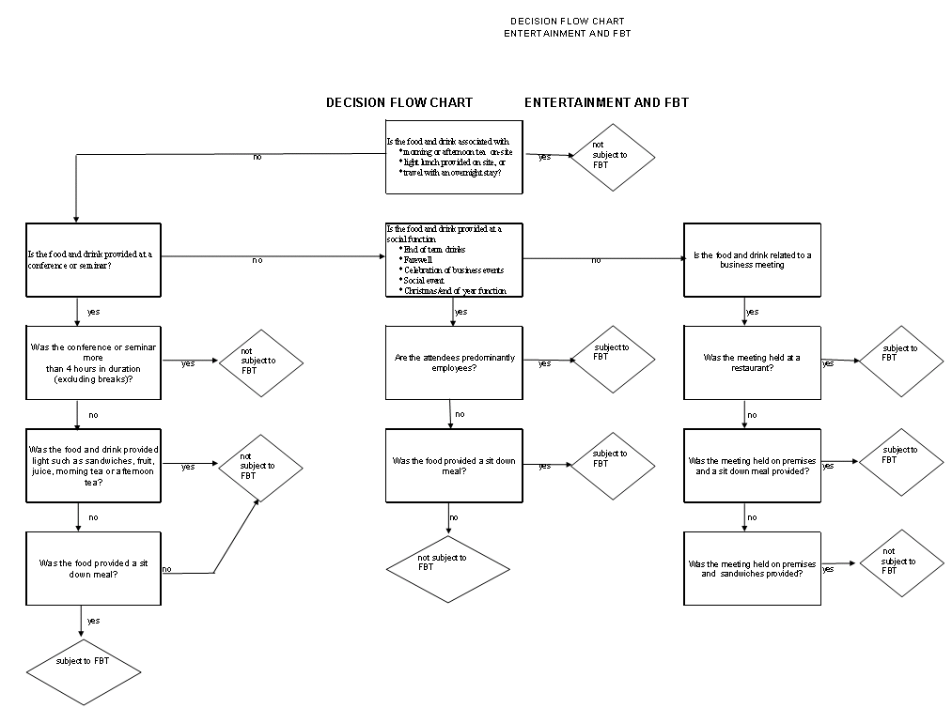

Link: www.sofweb/TaxResourceCentre/FBT/Appendix: School Entertainment Case Studies
What’s New?
Collegiate Schools Tax Audit Program (CR-STAP) Visits
As reported in last month’s Tax Briefs, in 2007 our STAP reviews will take a change in direction, with Tax Compliance Unit now having selected 14 school business managers to assist us.
The successful business managers, as listed below, attended a training day in early March and will be venturing out to conduct initial visits in conjunction with Wayne McKenna in Southern Metropolitan Region in Term 2 and Grampians and Eastern Metropolitan Regions in Term 3.

Name Region School
Cho Lay Gerrard BSW Corio Sth PS
Fiona Lucas BSW Montpellier PS
Jane Arnold EMR Badger Creek PS
Stacey Kerr EMR Emerald SC
Marje Brophy Gipps Korumburra SC
Barb Martin Grampians Buninyong PS
Greg Blatchford Hume Euroa SC
Fiona Heley LM Redcliffs SC
Glen Knight LM Eaglehawk SC
Froilan Altarez NMR Banksia College
Chris Confoy SMR Frankston HS
Diane Moore SMR Mornington PS
Diana Ortega WMR Essendon Keilor college
Sharon Ciantar WMR Braybrook College
What’s Old?
Running Balance Account - school BAS returns
A reminder from last issue that it is timely and good practice at the end of the school financial year (and leading into June 30), that ALL schools who submit their BAS electronically access the Business Portal at www.bp.ato.gov.au and down load a copy of their schools running balance account details.
The running balance account details can be run at any time by schools.
The running balance account details are a record of the school’s liability and payments as recorded by the ATO for each BAS lodged since July, 2000.
The balance of the account should be ZERO. (So no further action is required by school).
However, there will be instances where the balance of the account is in either DEBIT or CREDIT, which could be due to a number of possible reasons, including general interest charges, late lodgement penalties. In these instances the Business Manager (or other school authorised contact) should contact the ATO for advice.
Where schools do not submit their BAS electronically it is strongly recommended that the Business Manager or the person authorised to talk to the ATO, contact the ATO on 132866 and request a copy of the school’s running balance account.
Those schools who are not already submitting their BAS electronically may like to apply by accessing the above Business Portal at https://bp.ato.gov.au
What should I do this Month?

School Motor Vehicles Must Be Recorded on FBT Tracker
An observation from our STAP visits is that some schools need to update their CASES 21 Finance Asset Register and/or FBT Tracker vehicle information as the information in many cases is outdated or incomplete. In some instances schools have cars recorded that have since been replaced (sometimes several times over), with the replacement cars and disposal dates not recorded for replaced cars.
Correct vehicle details must be recorded in FBT Tracker. As a reminder it is imperative for the accurate calculation of the Departments liability that FBT Tracker includes all vehicles held during the FBT year along with purchase and disposal dates and opening and closing kilometres, as well as regular entry of ongoing vehicle usage.
End of FBT Tax Year Processing for Employees Salary Packaging
A reminder that Employees salary packaging a motor vehicle with SmartSalary are required to notify SmartSalary the odometer reading for the vehicle as at 31 March 2007.
Notification is to be made using the FBT declaration form that will be available online from 26 March to 12 April 2007 at www.smartsalary.com.au (the employee will be required to enter their SmartSalary username and password). Alternatively, employees can email their odometer reading to DET@SMARTSALARY.com.au between these dates. Enquiries should be emailed to SmartSalary (DET@SMARTSALARY.com.au) or by phone to 1300 550 056.

Tax Calendar for end of Term 1 & start of Term 2, 2007
21 March | February Monthly BAS due, including PAYG data.
1 April | FBT Tracker Nil Return opens for school entry
20 April | Final lodgement Date for schools to lodge FBT return on FBT Tracker
21 April | March Monthly BAS due, including PAYG data.
28 April | March Quarterly BAS due, including PAYG data.
Schools should progressively input entertainment and motor vehicle log sheet summary data throughout the year as it is incurred into FBT Tracker.

