HYIA CHANGE IN SIGNATORIES

I had a problem in October, and had to get Westpac in Melbourne to transfer some money for me to happen that day.

But I found out that our signatories on the account were the ones from when the account was open in 2000, this included our Principal that retired 3 years earlier. This had not been detected due to the fact that everything for HYIA is done by phone or by internet.

I was advised by Westpac that I needed to complete two forms available on-line, and get one signed by Regional Office, and send them both off in the mail.

The website is: www.westpac.com.au/government/vic

User Name: vicgov
Password: westpac2

You will then get the screen below.
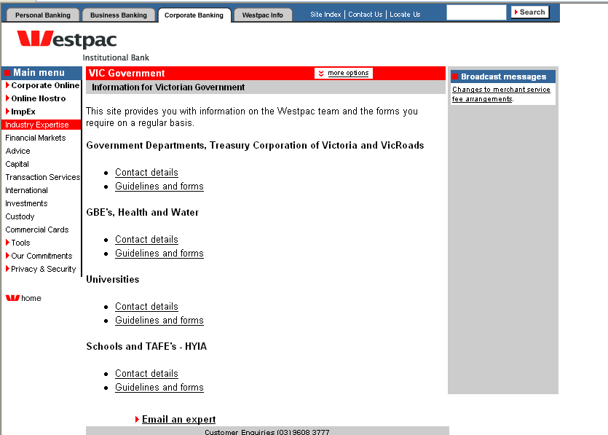

You will need to go to Schools and TAFE’s – HYIA, and select Guidelines and forms.

Then you will get the screen below.
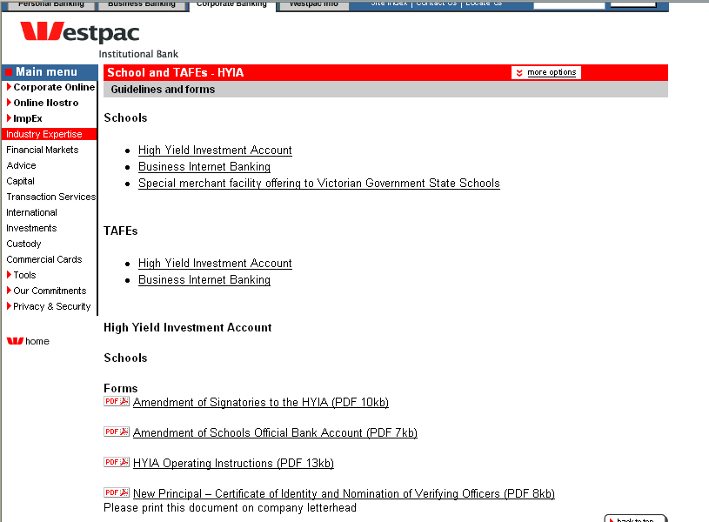
SEE PAGE 2
You will need to print out two forms:

- Admendment of Signatories to the HYIA
- New Principal – Certificate of Identity and Nomination of Verifying Officers (this one needs to be printed on school letterhead and signed by the Regional Finance Officer – Bill Harrison).

Once you have completed both forms, and got the second one signed by Regional Office, they need the originals to be sent by mail to:

The Manager
Global Transactional Banking
Westpac Institutional Bank
10th Floor
360 Collins Street
MELBOURNE VIC 3000

If you have any queries about who your school’s signatories are you can call: HYIA Inquiry Line – 9608 3058

