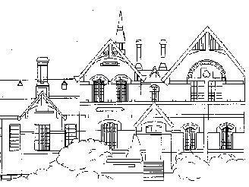
Auburn Primary School
Rathmines Road
Hawthorn East 3123

DAILY ADMINISTRATION OF MEDICATION

DATE:

PARENT’s NAME:

ADDRESS:

TELEPHONE:

(Business Hours) (Other contact number)

I request that my child ________________________ be administered the following medication
( Child’s Name )
whilst at school.

NAME of MEDICATION:

DOSAGE (AMOUNT):

TIME/S OF DAY:

YES / NO
REFRIGERATION REQUIRED: (Please Circle)

DATES OF DAYS TO BE ADMINISTERED:

I have sent the medication in the original container displaying the instructions provided by the pharmacist.
To be completed by the school.

Administered by: ______________________
PRINT NAME

______________________
SIGNATURE

Date & Time: ______________________

Yours sincerely

(Parent Signature)

Date: ____/____/____

THE INFORMATION COLLECTED WILL ONLY BE USED FOR THE PURPOSE OF ADMINISTERING MEDICATION AS REQUESTED.

To be completed by the school.

Administered by: ______________________
PRINT NAME

______________________
SIGNATURE

Date & Time: ______________________

To be completed by the school.

Administered by: ______________________
PRINT NAME

______________________
SIGNATURE

Date & Time: ______________________

To be completed by the school.

Administered by: ______________________
PRINT NAME

______________________
SIGNATURE

Date & Time: ______________________

To be completed by the school.

Administered by: ______________________
PRINT NAME

______________________
SIGNATURE

Date & Time: ______________________

