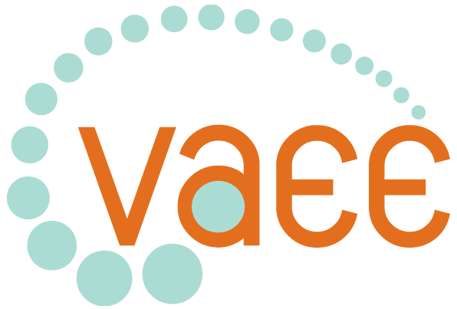
Victorian Association for Environmental Education
ABN: 51290873970
150 Palmerston St Carlton VIC 3053
Ph: (03) 9349 1806
Fax: (03) 9349 5758
Email: vaee@vaee.vic.edu.au
Web: www.vaee.vic.edu.au

EVENTS BOOKING FORM – SUSTAINABILITY LEADERSHIP & CHANGE

First Name Surname

Organisation Position

Postal Address

Suburb Post Code

Telephone: Work Fax Mobile

Email

Website

Are you/your organisation a member of the VAEE?  Yes  No Number Total
Workshop 6TH May 09 Sustainability Leadership & Change  $______

Cost per person:
VAEE member $200 non-VAEE member $250

Names of people attending: ____________________________________________________________
__________________________________________________________________________________
Total cost of booking (prices GST inclusive): _______

Bookings must be accompanied by Cheque / Credit Card details / or School Purchase Order Number
Cheque – Please find enclosed a cheque for $__________.
Please make cheques out to the Victorian Association for Environmental Education.
Please invoice_____________________ (school/organisation Name) Purchase Order Number___________

Credit Card – Please debit my credit card - .VISA / MC / BC

Card Number: --- Expiry Date /
Name on card ____________________ Signature ____________________Date_________

Schools only
 Catholic  Independent  DEECD (please indicate region below)
 Eastern Metropolitan  Northern Metropolitan  Western Metropolitan  Hume
 Southern Metropolitan  South Western  Loddon Mallee  Barwon
 Gippsland  Grampians

Dietary Requirements □ Vegetarian □ Vegan □ Gluten Free □ Other:
(indicate for each person)
We hope you enjoy this event!

